Queena Lin

CIS 350: Chapter 2

1. Write the business rule(s) that govern the relationship between AGENT and CUSTOMER.

One agent can have many customers but each customer has only one agent so there is a 1:M relationship between AGENT and CUSTOMER.

1. Given the business rule(s) you wrote in [Problem 1](javascript://), create the basic Crow’s Foot ERD.



3. Using the ERD you drew in [Problem 2](javascript://), create the equivalent object representation and UML class diagram. (Use [Figure 2.4](javascript://) as your guide.)

 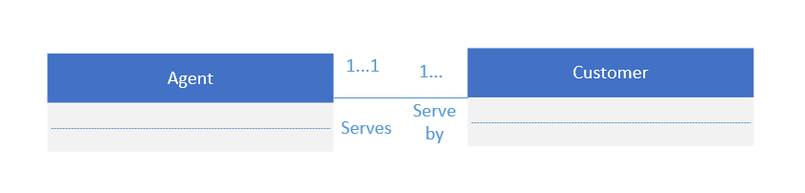

**Figure P2.4 The Dealco Relational Diagram**

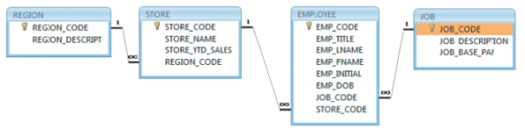

1. Identify each relationship type and write all of the business rules.

* The relationship between REGION and STORE is 1:M because each region can have multiple store, but each store is located on 1 region.
* The relationship between STORE and EMPLOYEE is 1: M because each store employs one or more employees while each employee can only be employed by one store.
* The relationship between EMPLOYEE and JOB is also 1:M because each employee can only have one job assignment while there can be multiple employee under the same job title. (This is only under the assumption that each employee can have only 1 job title, but does not apply to real life)

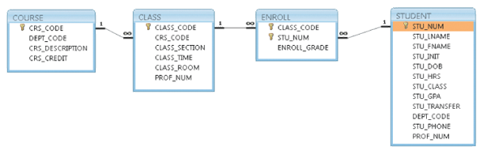

6. Identify each relationship type and write all of the business rules.

- All the relationship is 1:M

-COURSE generates CLASS. One course can generate many classes. Each class is generated by one course.

- CLASS is referenced in ENROLL. One class can be referenced in enrollment many times. Each individual enrollment references one class.

- STUDENT is shown in ENROLL. One student can be shown in enrollment many times. Each individual enrollment entry shows one student.

7. Create the basic Crow’s Foot ERD for Tiny College.



8. Create the UML class diagram that reflects the entities and relationships you identified in the relational diagram.

